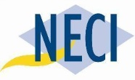
Building

Strong Procurement Teams since 1991

ENROLLMENT JUSTIFICATION TOOLKIT

How do you justify the expense? | How do you communicate the value of the training? | How do you share the benefits your training will bring to your organization?

How to justify the expense

Why Learn With NECI?  NECI has been providing public sector procurement professionals with the knowledge needed to successfully manage contracts, increase value, and reduce litigation risks for over 25 years.  We offer convenient training to fit your busy schedule. Choose from face-to-face, 100% online, or blended learning and stay current on emerging issues and best practices that your organization faces every day. | “The PSPP program provided me with the foundation to run a successful competitive bid project from cradle to grave all while improving critical thinking skills, and enabling me to become the preferred source of Procurement and Contracting expertise within my organization.”  Greg McLean  Procurement Specialist, Saskatchewan Research Council
"The deep discussions and case studies encouraged me to think of creative ways to solve issues, and enhanced my critical thinking skills. I would strongly recommend this program (PSPP) to all public procurement employees."  Ryan Chernoff  Senior Buyer, City of Kelowna | PSPP Offers Demonstrable ROI  Prior to embarking on each PSPP course you will complete an online multiple choice quiz designed to test your existing knowledge of the course content. The system records your pre-course score, and then you complete a similar but randomly selected set of quiz questions after completion of the course. Comparison of your pre and post course scores provides a concrete measure of your learning.

General Tips
To create a positive organizational ROI resulting from your enrollment:
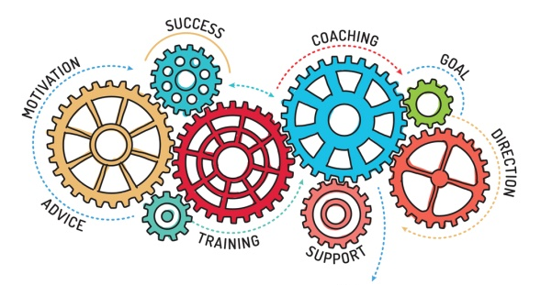 | - Focus what you bring back to your organization as a Return on Investment  - Commit to preparing a report on things you learned  - Deliver a presentation and Q & A to colleagues to share what you learned  - Point out that you can log professional designation maintenance credits, earning 95 contact hours  - Take advantage of the PSPP Bundle for a 20% discount and obtain just one approval

Approval Letter Template

Date _______

Dear (Supervisor's Name) _________

I would like to request that (Company name) sponsor my enrollment in the Public Sector Procurement Certificate Program (PSPP) through National Education Consulting (NECI).

NECI is Canada’s leading procurement training organization and the PSPP program is specifically designed to meet the needs of Canadian public sector professionals. The certificate program covers all phases of the procurement and contract management cycle:

- PSPP 101: Public Sector Procurement Essentials (or 101 Challenge)
- PSPP 201: Planning
- PSPP 202: Solicitation and Award
- PSPP 203: Managing and Evaluation
- PSPP 301: Procurement Practice – Putting it all Together

I believe participating in this program would greatly enhance my effectiveness in my procurement role and will reap benefits for (organization name). Here are a few examples of the benefits:

Easy access to unparalleled professional development. The PSPP is delivered entirely online through a highly interactive, synchronous delivery format. I can conveniently work it into my schedule and complete alongside my regular duties – no travel involved. Included in each 200-Level course is a weekly webinar with an expert procurement instructor. In these webinars, I’ll have the opportunity to ask questions and receive a more personalized and unique education.

Professional designation credits. I will log 95 contact hours with the PSPP which can be applied to maintenance of a wide range of professional designations.
Extensive tools and resources. I will have access to practical tools, templates, and the bi-weekly newsletter, The Legal Edge, that provides articles on current and pending legal developments, contracting law, and best practices.
Networking opportunities. I will join a cross-Canada cohort representing levels of government and organizations, gaining an unparalleled network of public sector procurement professionals, from peers to mentors, to industry leaders. After successful completion of the certificate program, I will join the NECI Procurement Community of Practices on LinkedIn.
The PSPP can be completed within one year, and the projected total cost for purchasing each course individually is $4889. If we purchase the PSPP Bundle (includes all 5 courses), we will receive an additional 20% off, which will bring our total cost down to $3,897.
I hope you will consider my request and grant me approval to become a PSPP participant.
Thank you for your consideration,
Sincerely
(Your Name)

